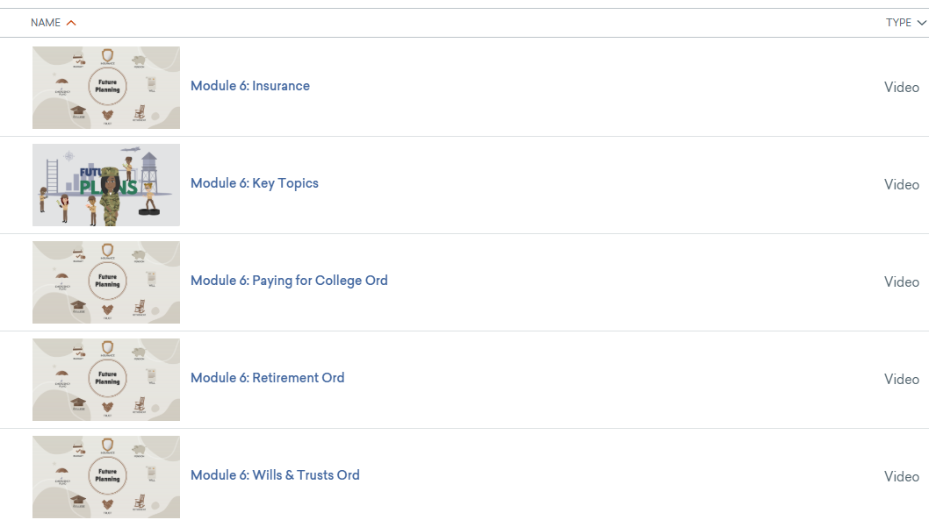 | Videos are created in Vyond
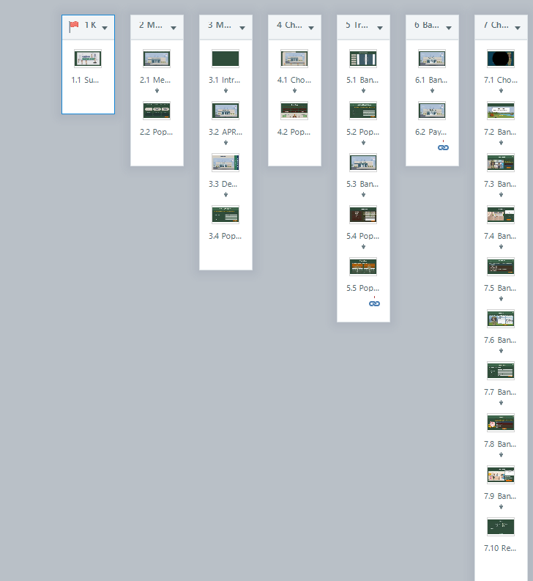 | Videos are uploaded into Storyline360. This platform includes: tabbed/carousal slides; quizzes/games  Each lesson is its own file. For example, to the left is 1 module with 7 lessons. The 7 lessons will be downloaded as its own file.  This module breaks down to:  7 separate files with a total of 35 videos
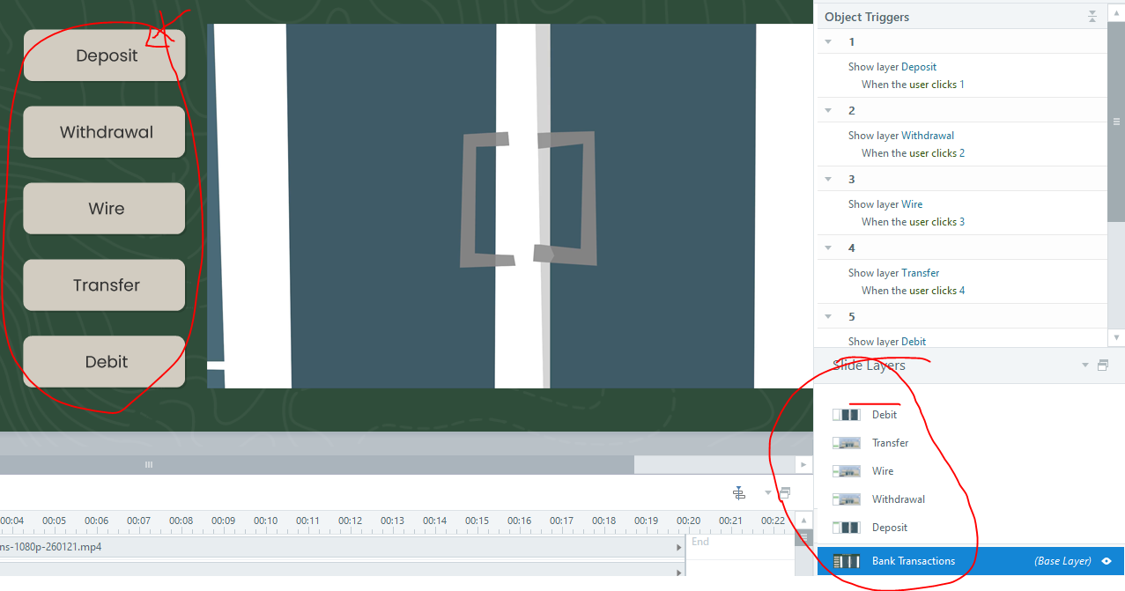 | EXAMPLE OF A TAB SLIDE  Tabs-left circle  Layers-right circle  This has a base layer and additional slide layers for the tab selection.
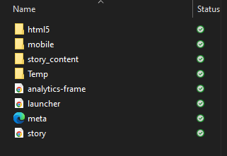 | In Storyline360; a lesson is published, creating files
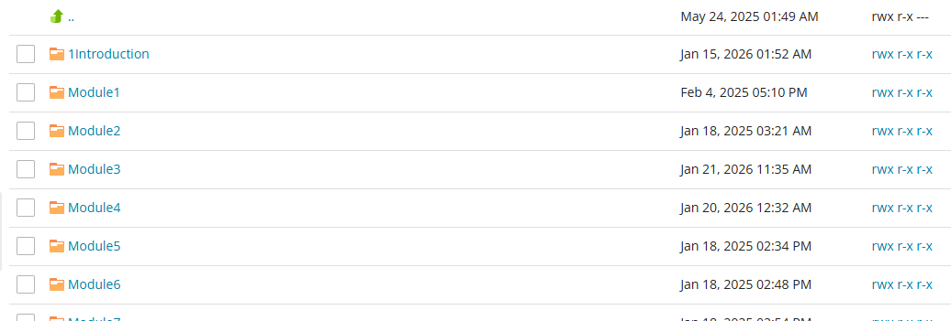 | Using FTP, I load the files on my server
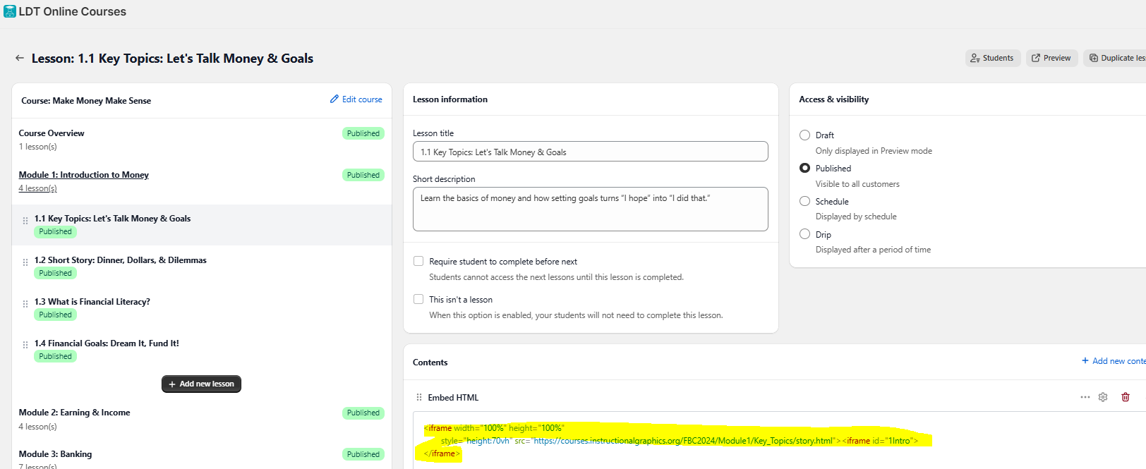 | Using LDT I have embedded code to access the files from my server.  Prior to moving to Shopify, The lessons had its own webpage with same embedded code. Using “WishList Member” to manage access for purchases

